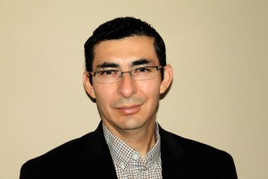
Arturo Pena Bios

Arturo was born in Arequipa, Peru, and moved to United States in his twenties. Since then, he has been managing large alpaca farm operations. His love for the Alpacas and his passion for its luxury product “The Fleece” motivated him to become an Alpaca Owners Association (AOA) Certified Judge in Halter, Fiber and Performance. In addition, Arturo currently serves on the AOA Judges Advisory Committee (JAC).

He is an alpaca expert with extensive knowledge in animal health, alpaca selection, genetics and management. He has an educational background in Veterinary Medicine and has a bachelor’s degree in Management. Before devoting fulltime to alpacas, he had planned, organized and executed Dog Shows while serving as Treasurer at the Regional Peruvian Kennel Club Association. He also worked as a Travel Agent at one of the prestigious agencies in Peru where he developed his passion for traveling. He also organizes educational trip to Peru.

Arturo has judged across United States, Canada and Europe. He strongly believes that education is the key to succeed in the alpaca industry. Through Judging, seminars, workshops and consulting, he has assisted and guided new and seasoned alpaca breeders to achieve their goals.

Along the way, he has been recognized as a collaborator of a scientific and biomedical research about “Antibodies from Alpacas as Tools to Study Virus-Host Interactions”. His co-authored scientific research study “Do Differences in Maternal Immunoglobulin G Influence Passive Transfer and Subsequent Cria Growth in Alpacas?” was accepted for publication in the prestigious scientific veterinary journal, Theriogenology.

Arturo and his family donate their free time at the local library and at Cornell University Cooperative Extension 4-H Putnam County doing what he knows the best: creating awareness about the alpaca industry and trying to make the difference in his community.

He lives in North Salem, New York with his wife, Kat, their son, Nicholas, and their dog daughter, Sabrina. They love to spend time outdoors and take alpaca pictures.

