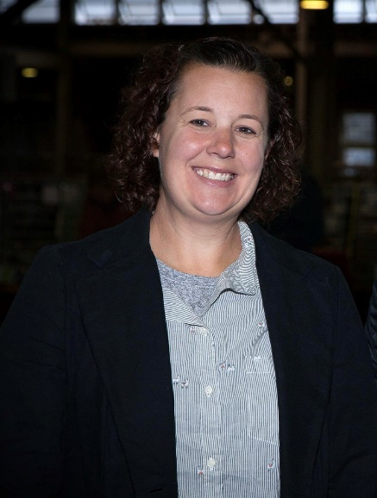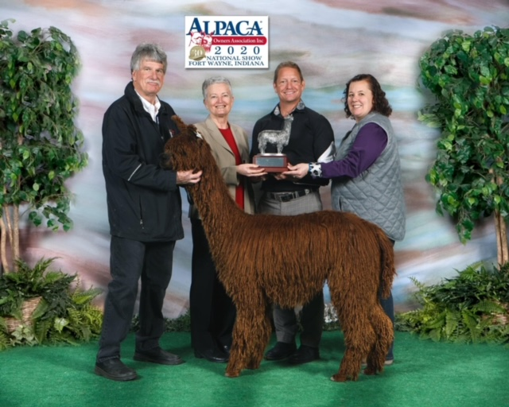

Stephanie Glyptis has been an active part of the alpaca industry for over 20 years and an alpaca judge for nearly 15 years. She currently holds certifications in Huacaya Halter, Suri Halter, Fleece, Walking Fleece, Performance and is a judge trainer in performance.
After graduating from West Virginia University with a degree in animal science, Stephanie Glyptis jumped into alpacas in 2000 as the herd manager for Heart's Desire Farm, the largest huacaya herd in West Virginia. This herd of nearly 300 kept her very busy halter training, delivering crias, and managing the daily needs of the alpacas. It was here that she was able to refine her eye for solid conformation in alpacas and develop her true love for them. A very active participant in the show ring while at Heart’s Desire, she was finally able to merge her background in dairy cattle judging with alpacas when she became an AOA Certified Judge.
As an AOA judge, she has judged all over the United States as well as in Canada. Whether in the show ring or in the fleece room, her love of alpacas and furthering the development of the stock of both huacaya and suri alpacas is able to come through with the exhibitors and volunteers.
Stephanie is also a current member of the JAC, the Judge Advisory Committee, with the Alpaca Owners Association and enjoys being part of the group that works towards evolving the judge standards and tools for our industry.
In 2015, she was able to start her own herd at Glyptis Manor Alpacas and focuses on producing seed stock with an emphasis in fawn alpacas. By owning alpacas, she has been able to influence the next generation of alpaca farmer and maybe judges as her daughter, Abigail, has grown to love alpacas and being in the show ring as much as her mother. With the support of her husband Phillip and farm help from son Teddy, Glyptis Manor Alpacas has grown to 10 alpacas that were all carefully selected for both their uniform fleece traits and solid conformation.
She can be reached at alpacasteph@yahoo.com, cell (304) 374-1363.

